==============================================================================
COMMAND:
<!DOCTYPE html>
<html>
<head>
<title>HTML Table and Form Example</title>
</head>
<body>

<h1>Practical 2: HTML Table Demonstration</h1>

<!-- Simple Table -->
<h2>1. Simple Table</h2>
<table border="1">
<tr>
<th>Name</th>
<th>Age</th>
</tr>
<tr>
<td>Krishna</td>
<td>18</td>
</tr>
<tr>
<td>Neelam</td>
<td>18</td>
</tr>
</table>

<br>

<!-- Rowspan Example -->
<h2>2. Table with Rowspan</h2>
<table border="1">
<tr>
<th rowspan="2">Country</th>
<th>City</th>
</tr>
<tr>
<td>Bharat</td>

</tr>
<tr>
<td>France</td>
<td>Paris</td>
</tr>
</table>

<br>

<!-- Colspan Example -->
<h2>3. Table with Colspan</h2>
<table border="1">
<tr>
<th colspan="3">Student Information</th>
</tr>
<tr>
<td>Name</td>
<td>Class</td>
<td>Roll No.</td>
</tr>
<tr>
<td>Krishna</td>
<td>FYCS C</td>
<td>1400</td>
</tr>
</table>

<br>

<!-- Simple Form -->
<h2>4. Simple HTML Form</h2>
<form>
<label>Name:</label><br>
<input type="text" name="name"><br><br>

<label>Email:</label><br>
<input type="email" name="email"><br><br>

<label>Message:</label><br>
<textarea name="message"></textarea><br><br>

<input type="submit" value="Submit">
</form>

</body>
</html>

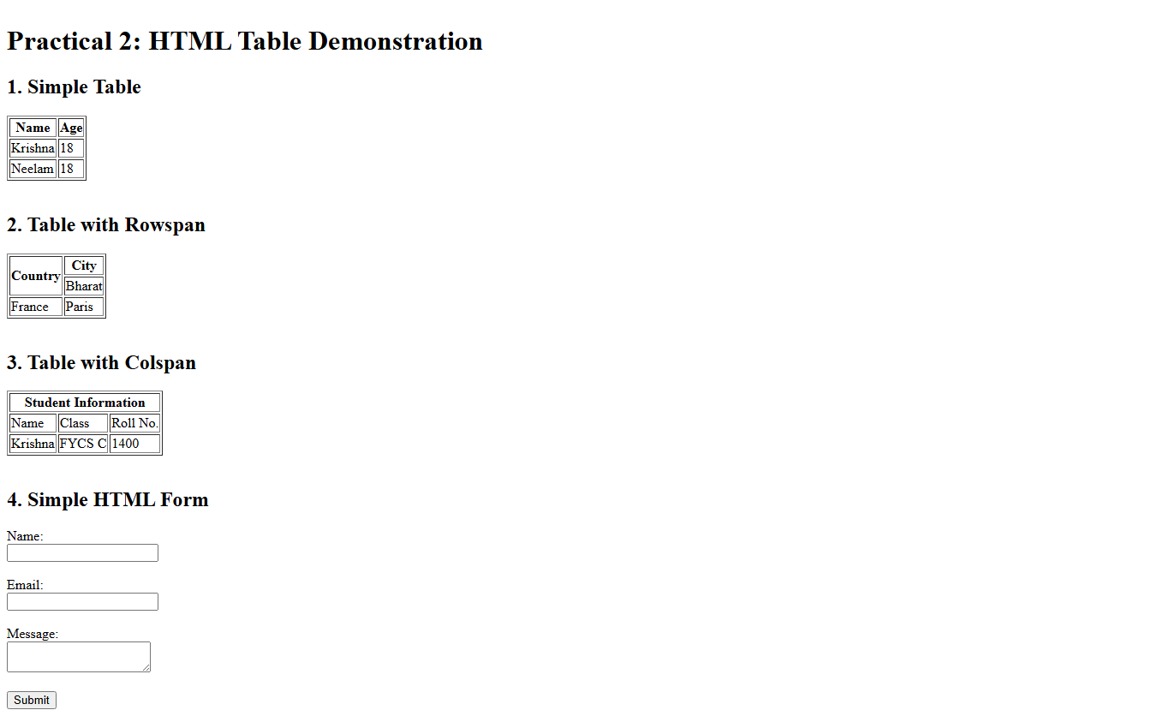
OUTPUT:

